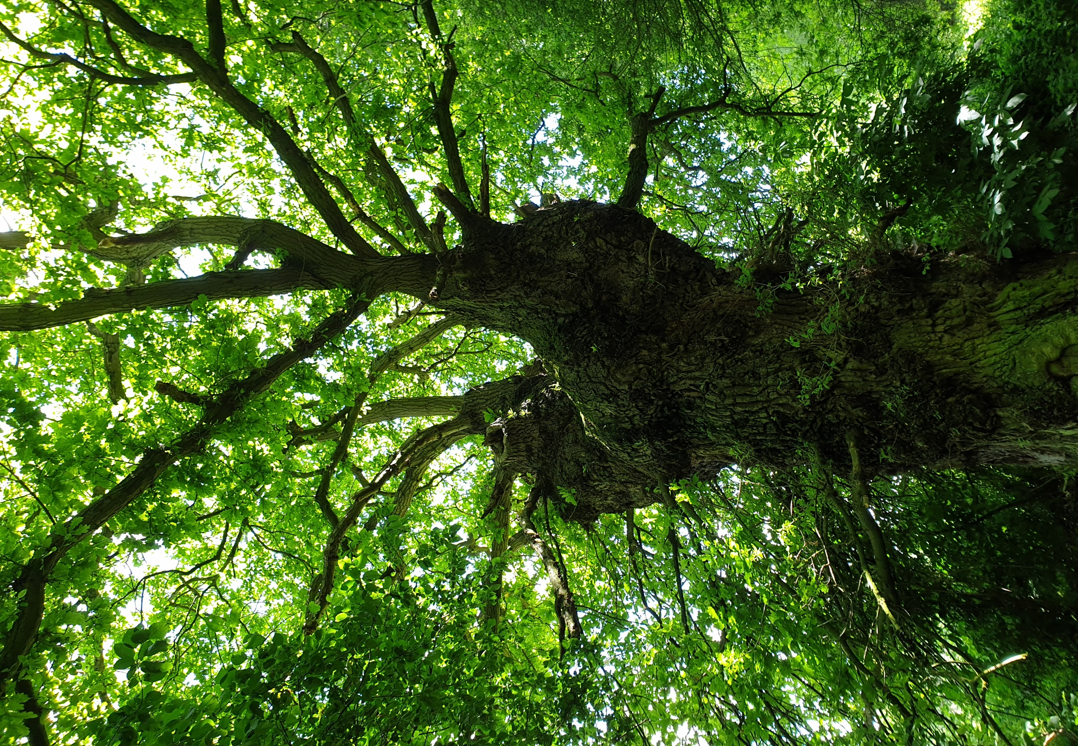
h
Essex County Council Tree Management Plan
May 2023
Contents
- The Essex Tree Management Plan Overview 2
- Benefits of Trees 3
- Policy Context 5
- The Essex Tree Estate 7
- Vision 8
- Aim 9
- Objectives 10
- Tree Planting Opportunities 12
- Tree Planting Principles 14
- Role of Tree Management Statements 14
- Appendices 15
11.1 Appendix 1: Types of planting……………………………………………………………………...15
11.2 Appendix: 2 Successful establishment ………………………………………………………...15
11.3 Appendix 3: Increasing species diversity…………………………………………………….…16
11.4 Appendix 4: Maximising the benefits……………………………………………………………16
11.5 Appendix 5: Retrofitting urban spaces………………………………………………………….17
11.6 Appendix 6: Biosecurity………………………………………………………………………….…….17
11.7 Appendix 7: Essex Forest Partnership…………………………………….…………………….18
11.8 Appendix 8: The Essex Green Infrastructure Strategy Tree
Recommendations………………………………………………………………………………………..18

The Essex Tree Management Plan Overview
There are over five million trees in Essex (BlueSky, 2017), and it is believed that
just over 1.5 million of these are outside woodlands in rural Essex and trees planted along streets. Almost all street trees in Essex are owned by Essex County Council (ECC). They help to define and frame the streetscape, providing visual identity and enhancing the street scene. There is also an approximate total of 12,500 km of hedgerow in Essex. Many of these hedges are adjacent to Essex Highways and their safety is the responsibility of the County Council.

ECC owns hundreds of thousands of trees across the land it owns and manages, from most of the trees on the streets and roads of Essex, to the extensive woodlands and hedgerows ECC owns in the countryside. These trees perform different positive functions depending on their context. For instance, street trees in urban areas shade and cool the residents from increasing temperatures associated with Climate change. Trees in rural areas perform many functions, including improving biodiversity and reducing flood risk. Essex County Council is committed to managing, improving and extending its tree stock.

This commitment is demonstrated at a strategic level at ECC, including via the council’s £200m four-year Climate Action Plan, published in November 2021. This plan fully endorsed the recommendations made in the report Net Zero: Making Essex Carbon Neutral (July 2021), by the independent advisory body, the Essex Climate Action Commission. The Climate Action Plan supports the Essex Forest Initiative with investment of £220,000 for 2022/23 - 2025/26, as in addition to a £300,000 grant from the Forestry Commission. The Climate Action Plan aligns with ECC’s organisation strategy, Everyone’s Essex. One of its four key strategic aims is for a High-Quality Environment, an ambition which is embedded throughout ECC processes, planning and strategic documents. Tree planting also forms an important part of the Essex Green Infrastructure Strategy (see Appendix 8: The Essex Green Infrastructure Strategy Tree Recommendations).

The ECC Tree Management approach is set out in this document, The Tree Management Plan, and a separate document, the Tree Management Statements. The approach adopted is informed by both ECC and external strategic plans in relation to the environment and tree management specifically. Details of these strategies can be found in the ‘Policy context’ section of this document.’

This Tree Management Plan has been formulated to set the Vision for our tree stock, our aim and objectives used in the management of existing trees and the planting of new trees in all parts of the ECC estate. Previously, there has been no formal Tree Management, however, with the emerging Climate crisis, the Council needs a robust plan for tree management and planting. The Tree Management Plan will outline the aim and objectives of the Council in relation to future tree management and tree planting.

The Tree Management Statements will outline how all trees in the Council’s portfolio will be managed and will consider directorate responsibilities. These statements will formulate the basis for future inspections, tree maintenance and tree planting.

Benefits of Trees

It is widely acknowledged that trees have multiple benefits that will enhance the lives of the residents across the County.

These benefits include:

- Locking up carbon
- Improving air quality
- Reducing flooding
- Reducing the “Heat Island Effect”
- Lowering the energy needs for adjacent buildings
- Improving biodiversity
- Increasing the value of properties nearby
- Improving local amenity
- Improving the mental and physical health of residents
- Increasing urban mobility by improving the quality of the public realm
The graphic below shows how trees promote health for an urban population.
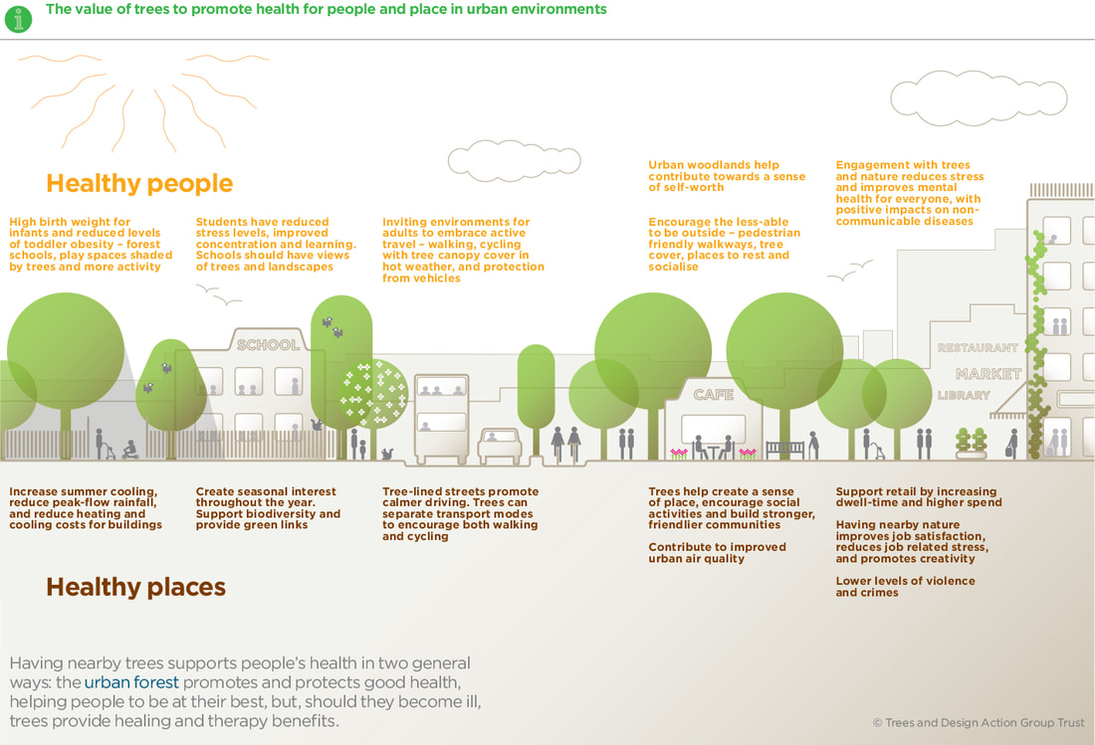
https://www.tdag.org.uk/trees-planning-and-development.html
Trees, Planning and Development: ﻿﻿﻿A﻿﻿﻿Guide for Delivery – Section One, Issue 1.2

The graphic below shows how trees keep our urban areas cool in the face of increasing summer temperatures as a result of Climate change.

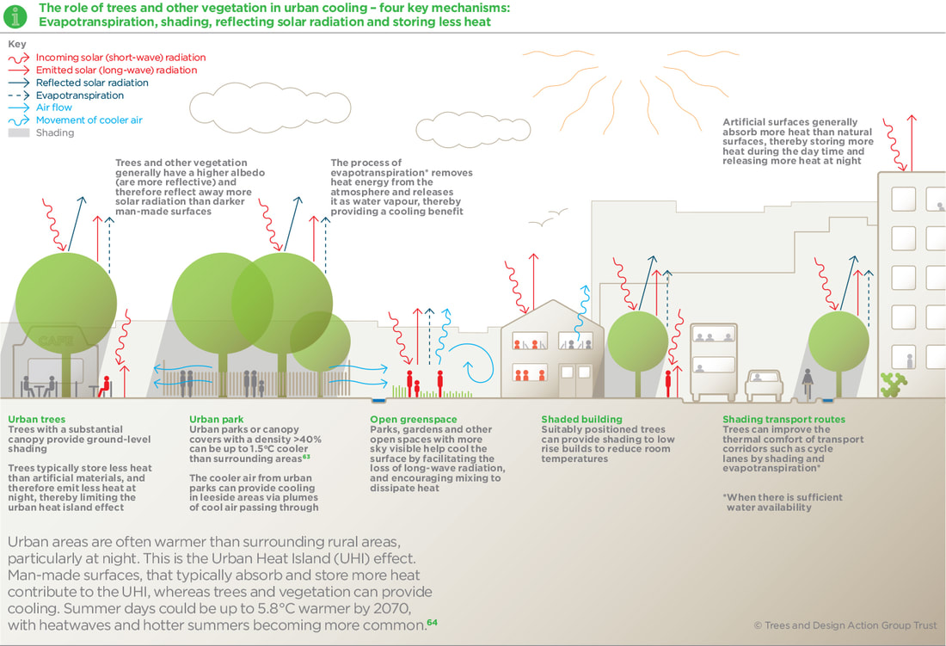
https://www.tdag.org.uk/trees-planning-and-development.html
Trees, Planning and Development: ﻿﻿﻿A﻿﻿﻿Guide for Delivery – Section One, Issue 1.2

This Tree Management Plan will help ECC reduce carbon emissions and help support net zero carbon targets in three ways. Firstly, the existing ECC Tree population hold considerable amounts of carbon locked up in the existing timber. The Tree Management Plan and Statements will improve the overall health of the tree population, thus retaining the carbon embedded in the trees for much longer periods. Secondly, by allowing for the healthier growth of the tree population, this will enable the existing tree population to grow further thus locking up increased amounts of carbon, in addition to the existing embedded carbon in the trees. Finally, the Tree Plan and Statements actively promote the planting on new trees throughout the ECC estate. These new trees have the greatest potential to lock up carbon from the date of planting. The Green Streets initiative on Essex Highways land will proactively assess sites for new street trees which will have enough space and favourable environmental conditions to ensure vigorous tree growth, thus locking up additional carbon for ECC. Choosing sites for planting carefully is important to avoid creating additional maintenance issues with the adjacent highway’s infrastructure – roads, footways, drainage. Where appropriate tree root retention infrastructure may also be needed to avoid root damage to adjacent public or private assets.

Policy Context
In recent years the UK has committed to adapt to and mitigate against the effects of Climate change. Increasingly it has published policies, plans and frameworks to guide this work, such as:

- 25 Year Environment Plan – HM Government (2018) [https://www.gov.uk/government/publications/25-year-environment-plan]

- The Environment Act – HM Government (2021) [https://www.legislation.gov.uk/ukpga/2021/30/contents/enacted]

- National Planning Policy Framework – HM Government (2021) [https://www.gov.uk/government/publications/national-planning-policy-framework—2]

- Sustainability and Climate change Strategy – Department for Education, HM Government (2022) [https://www.gov.uk/government/publications/sustainability-and-climate-change-strategy/sustainability-and-climate-change-a-strategy-for-the-education-and-childrens-services-systems]

- National Planning Policy Framework – HM Government (2021) [https://www.gov.uk/government/publications/national-planning-policy-framework—2]

- The England Trees Action Plan (2021-2024) – HM Government [https://assets.publishing.service.gov.uk/government/uploads/system/uploads/attachment_data/file/987432/england-trees-action-plan.pdf]

These documents have set out the important roles’ trees have to play in helping us adapt to Climate change and to mitigate against it effects.

In addition, Essex County Council has been proactively setting out how it will manage what has been referred to as the Climate crisis by publishing the following:

- Local Flood Risk Management Strategy – Essex County Council (2018) [https://flood.essex.gov.uk/media/1293/essex-local-flood-risk-management-strategy.pdf]

- Essex Green Infrastructure Strategy – Place Services, Essex County Council (2020): [https://downloads.ctfassets.net/knkzaf64jx5x/35jhjEoQZAc4f7bwGyLa38/fc90fbc5519874490047930aae371036/Essex_Green_Infrastructure_strategy.pdf] (See Appendix 8: The Essex Green Infrastructure Strategy Tree recommendations)

- Everyone’s Essex: our plan for levelling up the County – 2021 to 2025 – Essex County Council (2021): [https://assets.ctfassets.net/knkzaf64jx5x/QfCTFvZFWm6jBFzKIcxU8/3033e555110ddb553603919ae00c638d/ECC-Everyones-Essex-plan-2021-to-2025.pdf]

- Net Zero: Making Essex Carbon Neutral – Essex Climate Action Commission (July 2021): [https://assets.ctfassets.net/knkzaf64jx5x/1fzMJKNmIfz8WHx4mzdy2h/e7c57523466f347fd6cdccb3286c113c/Net-Zero-Report-Making-Essex-Carbon-Neutral.pdf]

- Climate Action Plan (four-year £200m action plan) – Essex County Council (November 2021): [https://assets.ctfassets.net/knkzaf64jx5x/4Ihrw6uXe2g19YxYWkfsk6/eba8f76776738b010f21d3e7f3b9add2/9422_Climate_Action_Plan_Report_v3_-_Digital_Accessible.pdf]

These documents all reference the importance and multiple benefits of Green Infrastructure and specifically trees and woodlands. They provide guidance on the need for trees and the management of trees in the ECC estate.

As we become increasingly aware of the effects of Climate change, ECC continues to develop strategies to help Essex to adapt and mitigate the impact of Climate change. Currently, ECC is preparing:

- The Local Nature Recovery Strategy
- The Essex Water Strategy
- Local Flood Risk Management Strategy (Updated)
- The Essex Highways Place & Movement Strategy

These will be published in 2023, providing more context for the strategy.

There are a number of tree maintenance and management guidance documents that have been used to formulate statements and policies in order for ECC to be compliant with best practice. These include:

- Trees in Hard Landscapes, A Guide for Delivery – Trees and Design Action Group (2014) [https://www.tdag.org.uk/uploads/4/2/8/0/4280686/tdag_trees-in-hard-landscapes_september_2014_colour.pdf]

- Manual for Streets – HM Government (2007)
[https://www.tdag.org.uk/uploads/4/2/8/0/4280686/tdag_trees-in-hard-landscapes_september_2014_colour.pdf]

Combined, these documents have been used to formulate management statements that provide a high standard for the Council.

The Essex Tree Estate
Essex, from the A road verges and country lanes, to town and city streets. On those verges and roads, ECC owns thousands of trees in all different growth stages. ECC also owns a substantial estate of buildings, including but not limited to: ECC Offices, Schools, Libraries, Adult Community Learning Centres, Nurseries and Youth centres etc. These buildings are generally set in urban areas and around these buildings are car parks, green infrastructure, and substantial tree numbers.

In the rural areas, ECC is a large landowner, owning 755 hectares of Country Parks, which includes a large percentage of woodland. It also owns 130 hectares of other woodland, four Outdoor Pursuits Centres and 412 hectares of Rural estate. In recent years, the Essex Forest Initiative has planted 29,000 young trees on two new ECC sites covering 14 hectares.

Collectively, the various land-owning Directorates will now have a united vision in relation to tree management and planting. The Tree Management Plan and statements will vary between these Directorates, as they have differing requirements for tree planting and management. However, all aim to enhance the contribution of trees within the sites.

The significance of the ECC tree stock is mostly in the mature woods, hedgerow trees and larger trees along roads and on the built estate. Larger, older trees, hedges and woods have great value for screening, aesthetics, biodiversity, carbon capture, shading for urban heat islands and flood retention. As a result, the ECC tree stock is very valuable and cherished by local communities and, as custodians of this valuable green infrastructure, the creation of this Tree Plan is very timely. Thus, this plan seeks to:

- Maintain and manage the existing tree stock

- Plant new trees to enhance the overall ECC tree stock

It should be noted that the principally mature woodland and trees hold very large quantities of carbon and their retention through good management (including good biosecurity measures, see Appendix 6: Biosecurity) will ensure little of this carbon is released to the atmosphere. In addition, the planting of new trees will lock up further carbon. The planned 375,000 trees of the Essex Forest Initiative are estimated to lock up 60,000 tonnes of carbon over the lifetime of the trees.

Vision
That Essex County Council will lead the way on creating 30% Natural Green Infrastructure by protecting and increasing the tree stock on the Essex County Council estate.

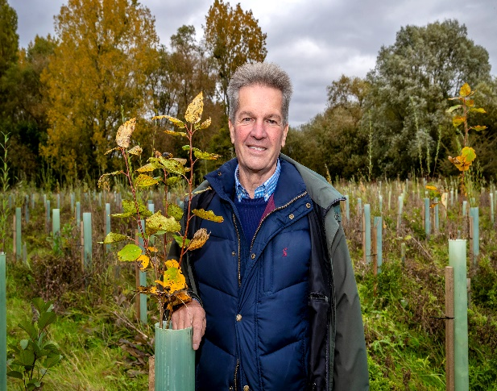
Cllr Peter Schwier with newly planted trees at Chelmer Valley

Aim
Essex County Council aims to improve the quality and impact of its tree stock both through good management of existing trees and strategic planting of new trees to enhance the multiple benefits provided by a diverse tree population.

Objectives
Objectives The overarching objectives for tree management and planting are:

- To protect and manage the health and safety of the existing trees to maximise the multiple benefits the trees provide

- To increase the number of new trees in the Essex County Council estate to maximise the multiple benefits the new trees provide.

The Council will protect and manage the health and safety of the existing trees by inspecting trees across the whole ECC estate and recording those that need work or more frequent inspection. Whilst carrying out these inspections of the existing trees, opportunities for new tree planting will be identified and planted.

Every opportunity will be taken to seek external additional funding streams to enhance and add to the ECC tree stock.

Objective 1: To protect and manage the health and safety of the existing trees to maximise the multiple benefits the trees provide

A priority of the Tree Plan is to establish to size of the tree stock and assess its health.
This should be done in Essex Highways, the Schools Estate and the built estate (EPF), where ECC will aim to carry out regular inspections at least every three years, recording these trees on a tree management system Trees in urban areas are generally the most beneficial to a large proportion to the Essex population and are also often the most cherished of trees with high aesthetic and emotional values to local communities. Those in urban locations also require most health monitoring, so they are not a risk to people or property.

Assessment of tree and woodland health will also take place in the areas of the rural estate where there is public access. This includes Country Parks and woodlands which are publicly accessible, as well as mature hedgerow trees adjacent to new planting areas.

The new process for managing trees across the County will be reliant upon a tree management system, which will be trialled on Essex Highways land and accessible to both the Place Services Arboricultural team and the Essex Forest Initiative team. There will be multiple uses for this system (Ezytreev©):

- To record all surveys of sites within the Council’s ownership
- To record all trees that either require maintenance work (singular or repeat), as well as mature specimens that require more frequent inspection
- To manage all tree work resulting from inspection, from quotation through to completion and ensure traceability of this
- To ensure that the ‘duty to consult’ and issuing of s154 notices is carried out in line with government guidance
- To record all suitable planting locations in the ECC estate, recommending species and planting requirements

The process for inspecting and recording trees is set out in the Management Statements document.

Objective 2: To increase the number of new trees in the Essex County Council estate to maximise the multiple benefits the new trees provide

Essex has a long history of planting trees. In the 1980s, Essex was amongst the first Councils to encourage landowners to restore hedges. In 1990, ECC was the lead Authority to establish one of the first three Community Forests in England (Thames Chase), which still exists today and has planted over 1.3 million trees. In c.2010, ECC committed to plant 250,000 trees across Essex.

In July 2021, the Essex Climate Action Commission (ECAC) published ‘Net Zero: Making Essex Carbon Neutral’, which outlines the importance of tree planting as a method of offsetting the effects of Climate change, including locking up carbon, reducing surface water flooding and reducing the urban heat island effect. The report promotes trees as part of new developments, as well as retrofitting trees into existing grey infrastructure. In November 2021, Essex County Council endorsed the ECAC report in full and developed a £200m four-year Climate Action Plan to support delivery of the recommendations.

At a UK Government level, The England Trees Action Plan (2021-2024) [https://assets.publishing.service.gov.uk/government/uploads/system/uploads/attachment_data/file/987432/england-trees-action-plan.pdf ] commits to increasing tree planting to mitigate Climate change. This commitment is further supported by the National Planning Policy Framework (2021) [https://www.gov.uk/government/publications/national-planning-policy-framework—2], which has an aspiration for all new streets to be “tree lined”.

Essex County Council’s four-year Climate Action Plan encompasses support for the Essex Forest Initiative (EFI) team, which is responsible for the planting of 375,000 trees between 2020 and 2025. As at March 2023 EFI had planted 240,000 trees. The Essex Forest Initiative has also coordinated the Essex Forest Partnership (see Appendix 7: The Essex Forest Partnership), which has a collective ambition to plant one million trees in the County across the 12 Essex Local Authorities.

Tree Planting Opportunities
There are a number of opportunities ECC has begun to explore in order to increase its tree stock:

- Identifying new tree planting opportunities in the Highways and wider ECC estate as part of the tree inspection process
- Replacing the recently) felled trees on the highway network in accordance with the tree planting principles in this plan.
- Creating tree lined streets and roads by retrofitting trees, utilising existing or new funding programmes (see Appendix 5: Retrofitting urban spaces)
- Working with schools and ECC School Planning team to plant new trees on existing and new sites

The Essex Forest Initiative has unlocked substantial funding from Forestry Commission schemes, voluntary sector organisations and numerous private sector companies to fund the new tree planting and the establishment costs.

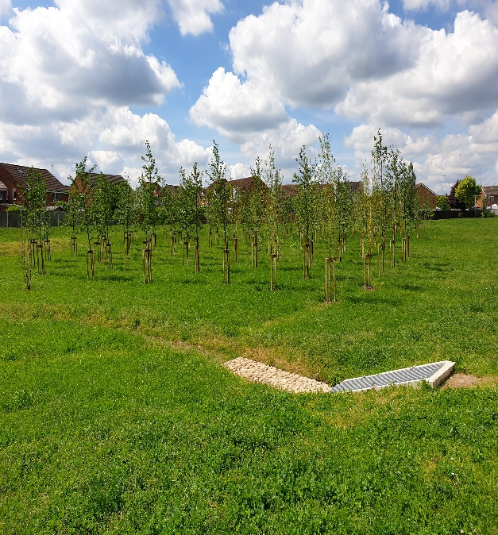
Trees planted as part of an ECC flood alleviation scheme in Maldon

Tree Planting Principles
In order to maximise the impact of the new tree planting stock, ECC will adopt the following principles:

- Plant the appropriately sized trees (Appendix 1: Types of Planting) for the space e.g., small trees in small spaces and big trees in big spaces
- Plant the appropriate tree species, size, and density in accordance with the Essex Highways Place and Movement Strategy (due out in 2023)
- Plant trees in appropriate locations, to make it unlikely that a tree will cause damage or create liability for the council (see appendix 4)
- Employ the appropriate watering, weeding and inspections in order to ensure successful establishment (see Appendix 2: Successful Establishment)
- Use a diverse range of species to combat diseases and Climate change challenges (see Appendix 3: Increasing Species Diversity, and Appendix 6: Biosecurity)
- Maximising multiple benefits, whether this be a reduction of emissions, improved shading on a footpath or reducing surface water flooding on a road (Appendix 4: Maximising the benefits)
- Using sustainable tree planting techniques such as using less plastic, sourcing local materials, and eliminating chemicals.
- Utilise surface water to irrigate the new trees and provide flood retention
- Use best practice management in relation to biosecurity
- Involving the local community where practicable to do so

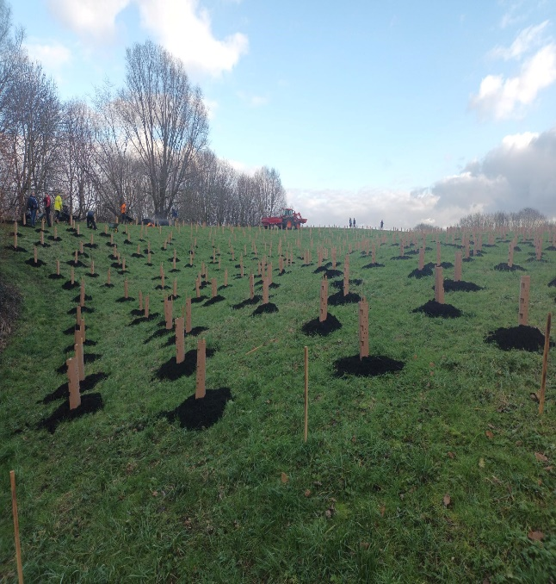
Newly planted trees in partnership with Basildon Council on
north facing slopes in Basildon

Role of the Tree Management Statements
To set out how the Council will manage its trees and comply with some of the detailed requirements of this plan the Council will produce Tree Management Statements which are consistent with the Vision, Aim and Objectives set out in this Plan.

The Tree Management Statements will outline how existing trees under the management of ECC – as well as new and yet to be planted trees – will be managed.

They will balance the responsibility of the Council to safely maintain its tree stock, whilst also maximising the multiple benefits trees provide to the environment and communities, including aiding the County’s work to reach Net Zero.

Appendices

11.1 Appendix 1: Types of Planting

Mature trees (standards)

Mature trees (standards) will predominantly be used in the urban environment and will be either “select standard” (10-12cm)heavy standard” (12-14cm) or “extra heavy standard” (14-16cm). They will either be container grown or root-balled specimens, with both methods giving the best rooting environment for a newly planted tree.

Where appropriate, specific engineering solutions may be incorporated into tree pit design to prevent damage to adjacent infrastructure. This may be a root barrier, to prevent roots from extending beyond the available space, or a root deflector, which will encourage root growth in an opposite direction.

Support will be needed for these trees for the first two growing seasons post planting and will either use a single or double stake (with potential for crossbar if necessary) system with appropriate tree ties. The ties will be checked, and any necessary formative pruning carried out alongside watering visits. After two growing seasons, any support systems must be removed to ensure that the tree will strengthen its stem to provide its own support long term.

These trees will be procured from nurseries with high quality biosecurity processes and renowned for their tree quality to give every tree the best chance of establishment.

Saplings (whips)

Saplings (whips) will be used to create new woodlands, copses, and hedgerows. These will also be sustainably sourced, ensuring all biosecurity measures have been adhered to. These plants are only available in the winter months and therefore planting will only be carried out between November and March. Predominantly whip planting will be limited to rural and semi-rural areas where woodland and hedgerow creation is appropriate, however increasingly we are seeking to bring nature into our urban areas. These areas will be more densely planted, and a range of pioneering and successional species will be used to ensure the quickest establishment but longevity of planting.

11.2 Appendix 2: Successful Establishment of new trees

All new planting will be recorded on the tree management system, and this will allow for maintenance and aftercare to be suitably managed and monitored. Using the correct size tree and species for the location will be key to making sure the tree has the best chance at establishing. It is preferred by the Council that a minimum of selected standard size trees will be used as these are big enough to survive in a new environment, but small enough that they will have time to adapt to their new location.

Young tree maintenance and watering will also be carried out for a minimum of three years after planting. This will include formative pruning, watering and removal of stakes/ties when necessary. Watering of the standard trees will be carried out at a minimum of 20 times during any growing season and where appropriate watering bags will be used to release the water more slowly to mimic rainfall. All watering and maintenance will be recorded so detailed records are held for each tree planted.

Where whips are planted, they will be planted with suitable guards to prevent pest damage but will be as sustainable as possible. They will be procured locally and where possible, will be biodegradable. Given that these trees need very little water to establish, they will not be watered post planting.

Tree survival relies on reducing competition from weeds etc. Historically, this was done predominantly through herbicides. However, more often now in Essex green waste mulches are being used to shade out weeds and retain moisture which benefits the trees.

11.3 Appendix 3: Increasing Species Diversity

Part of resilience in an urban forest is the use of different species and size of trees to help the tree stock to persist through incumbent pest and disease outbreaks and through changes to the climate.

When trees are planted, the species will be carefully considered. The tree will need to be a suitable size for the location it is being planted in but will also need to be diverse from those already present. The risk of having too many of the same species is that it leaves the population exposed should any threat cause mortality, which as we have seen, can cause devastation in tree populations. Given that Climate change is likely to have further impact on the native species present within the UK, experimenting with new species and cultivars will enable the Council to have a better understanding of how developmental trees can enhance the local landscapes in Essex.

With the new management system and management processes, the Council will start to get a better understanding of the trees that are present on the estate, providing greater insight as to the tree species that are most likely to require work and their location. This information will continue to be built upon and will enable a stronger position for species diversity in the future.

11.4 Appendix 4: Maximising the Benefits

Through smart design and well thought out planting locations, the effects of Climate change and the effects of poor air quality can be reduced for users of an area. Whether this be a reduction of emissions, improved shading on a footpath or reducing surface water flooding on a road, choosing the right tree for a location can have a real impact on the quality of an area. Identifying the goals for planting early on will enable those designing an area to maximise the benefits of new trees. Essex County Council will aspire to always seek the maximum benefit of tree planting and where this can be done in collaboration with other teams, consultation will be made prior to species/planting pit specification, in order to ensure that maximum benefits are realised.

Trees can also have a negative impact on an environment if planted in the wrong location. A large proportion of Essex sits on London clay, which is known for causing tree related building subsidence. Locations will be suitably assessed prior to any decision on planting as to whether any damage is probable and if so, the area will either be planted with a specimen whose ultimate size and influencing distance is appropriate, or not planted at all.

11.5 Appendix 5: Retrofitting Urban Spaces

Retrofitting urban environments is an effective way to increase canopy cover. However, it does come with its own challenges. With underground and overground services already located, infrastructure already in place and often lots of hard surfacing, it can be difficult to create suitable environments for trees to grow.

Retrofitting trees into an established grey infrastructure environment can be expensive, as some tree pits would not only need to be designed around existing constraints but would also need to accommodate sufficient soil volume and permeable surface area to support root growth and development for the duration of a tree’s life. Whilst costly, the creation of such an environment should mean the tree can thrive during its natural lifespan and will prevent the need for frequent replacement of young and semi-mature trees.

Whilst the locations for this kind of tree planting are not currently recorded, once proactive surveys are undertaken, opportunities for new tree planting where sites are not encumbered by grey infrastructure will be identified for future planting and recorded. The locations and finance required to support such undertakings will be selected specifically where there will be the most benefit from the presence of trees.

11.6 Appendix 6: Biosecurity

The Council will use best practice management in relation to biosecurity. The Forestry Commission has extensive guidance on biosecurity that will be followed. The best practice in this guidance includes:

- Keeping footwear clean
- Cleaning vehicles regularly
- Not letting mud accumulate on wheels or tyres
- Keeping tools and equipment clean
- Using disinfectant on high-risk sites

The full guidance is available here: https://www.forestryengland.uk/sites/default/files/pdf/Biosecurity%20Policy.pdf

11.7 Appendix 7: Essex Forest Partnership

Collaboration is key to ensuring that the new woodlands of Essex can be enhanced as a whole, rather than by individual landowners. The EFI team have worked with partners to create the Essex Forest Partnership (EFP), which consists of tree and landscape officers from across all the cities, districts and boroughs of Essex. Meetings are held quarterly and involve sharing of information and the organising of site visits to explore how tree planting is being carried out across different authorities. The EFP can also start to address challenges which are being consistently faced by local authorities and share ideas on how they can be overcome. The EFP aspires to collaborate on developing guidance documents and supplementary planning guidance to ensure consistency and mutual support across the County.

11.8 Appendix 8: The Essex Green Infrastructure Strategy Tree Recommendations

Public Realm Green Infrastructure Improvements include:

- More street and urban planting (e.g., trees, hedges, green walls and roofs)
- Retention of trees and develop local targets for increasing tree and woodland cover
- Explore and implement an Essex Green Permit scheme to actively engage people to adopt, green up and manage land within the public realm
- Planting and retaining of trees, low hedges and other vegetation alongside roads act as porous bodies that influence the distribution of pollutants and improve air quality by absorbing through leaves, plant surfaces and the bark.

This information is issued by:
Essex County Council
Contact us:
Arboriculture@essex.gov.uk
Place Services
Essex County Council
County Hall, Chelmsford
Essex, CM1 1QH
Essex_CC
facebook.com/essexcountycouncil
The information contained in this document can be translated, and/or made available in alternative formats, on request.
Published May 2023

