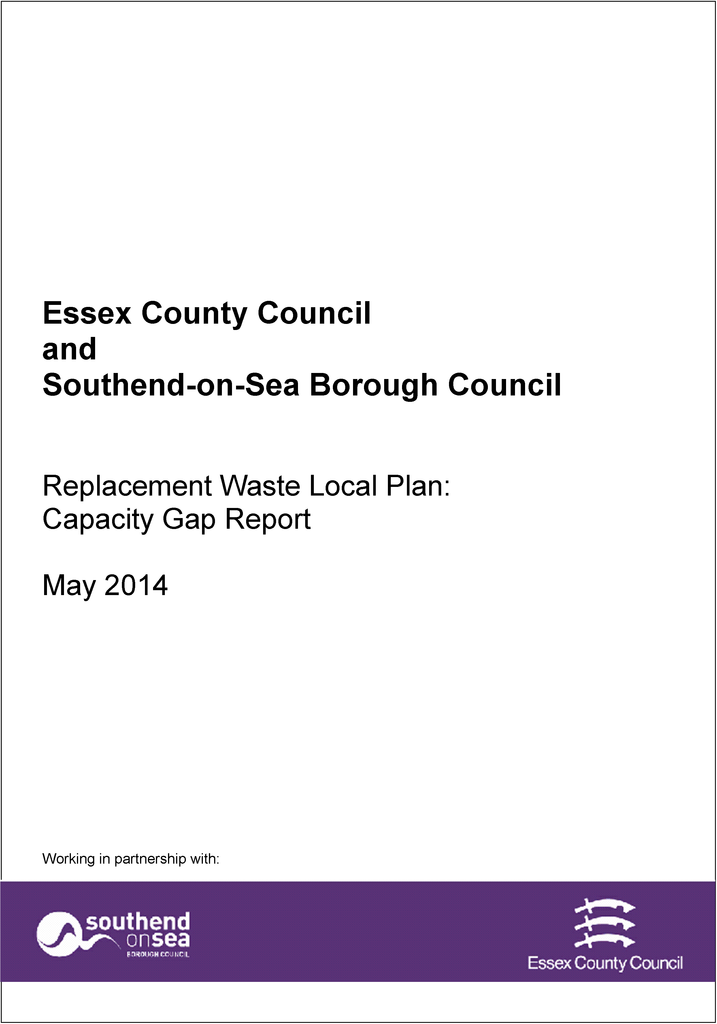

1 April 2023

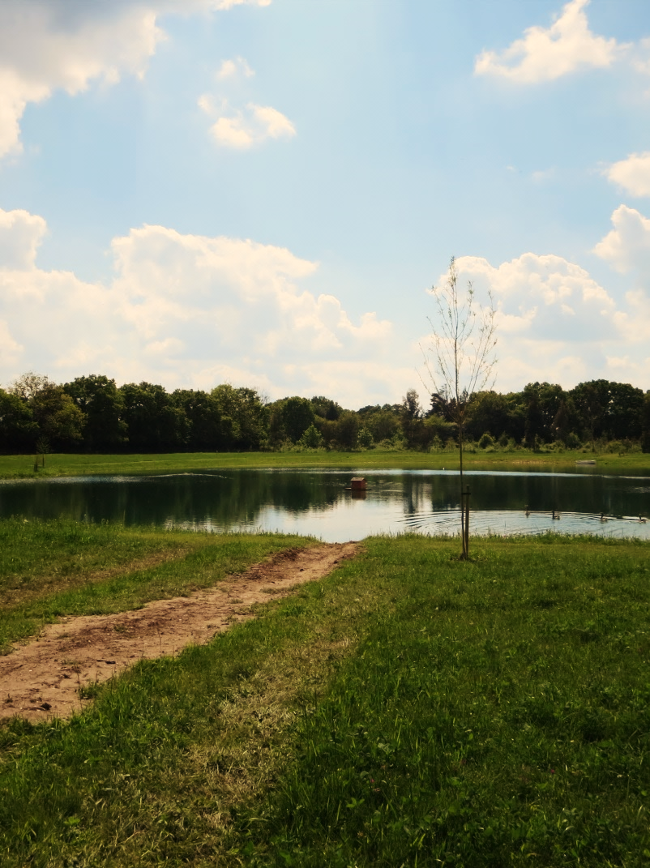

# Pre – Application Planning Advice

# Charging Schedule & Guidance

# Development Management

# Planning Advice - Guidance Notes

Essex County Council encourages you to seek advice before submitting a planning application. This advice gives you a better idea about the prospects of an application being successful as well as issues that will need to be considered when developing your proposals. It also helps to ensure that you include all the relevant material (drawings and other information) when you submit an application which leads to a quicker and smoother process. Guidance can also be given whether any pre-application public involvement is required.

Requesting Pre-Application Advice

You will need to complete the [Request for Planning Advice](https://www.essex.gov.uk/pre-application-advice)form. Advice for completing the individual sections appears below. Please provide as much additional material as possible, such as plans and photographs, in order that the officer(s) can carry out any necessary preparation prior to providing the advice or prior to a meeting (where requested) so that maximum benefit can be gained from the discussions.

## Applicant details

Please enter the details of the prospective applicant for the proposal.

## Agent details

If you are an agent working on behalf of the applicant, please enter your contact details in this section. If this section is completed, all correspondence will be sent to the agent.

## Interest in Property/Land

Please state what relationship the applicant has with the property or land (e.g. landowner) which is subject to the advice and whether other parties have an interest.

## Location of Proposed Development

Please provide the full address of the proposed site including postcode where available. If the site does not have a postal address, please provide a clear and accurate description of the location and a grid reference if possible.

## Basic Information

Please provide a description of the nature of the proposed development and any key details. Please provide as much information as possible to help us to provide more detailed advice. You should include a full description of the proposal including a breakdown of the site and schedule of proposed uses, details of what is considered to be the existing use of the site and likely timescales for the development and any other information which may be important in regards to the application site.

## Information Required

Please confirm that you have provided the required information and indicated any supporting documentation you have included with your request. Again, the more information you can provide, the more comprehensive our advice can be. The following list provides examples of types of supporting information which may be relevant to your proposal but is not exhaustive.

* A site layout plan of not less than 1:500 scale. All requests for pre application advice must include a plan sufficient to identify the location of the site. This should be based on an up-to-date Ordnance Survey map. The plans should identify sufficient roads and/or buildings on land adjoining the site to ensure the exact location of the application is clear. The inclusion of place names may be helpful. The proposed application site should be clearly edged with a red line and any other land in the same ownership should be surrounded by a clear blue line;
* Drawings and sketches of the proposed development, including, elevations, floor plans, cross- sections and ground levels;
* Block Plan;
* Photographs showing the existing appearance of the site;
* Any additional drawings that help to demonstrate how the proposal relates to its surroundings;
* A draft design and access statement if appropriate;
* A draft supporting planning statement if appropriate;
* Details of consultations undertaken already, e.g. Highways Authority;
* Area to list any further information that may assist the planning authority in preparing the advice.

In order to accept a request for pre-application advice the LPA will require, as a minimum, a red line site location plan and supporting details outlining the proposed development. Depending on the type of proposed development, there will be other requirements, as outlined below:

For minerals and waste development, required information will normally include:

* The type of development proposed (e.g. mineral extraction, waste transfer etc.);
* The type of waste;
* Proposed annual tonnages/volumes;
* Proposed vehicle movements and access point.

For County Council development (Regulation 3), required information will include:

* The location of the proposed building(s) and/or highway(s);
* The proposed use;
* Proposed floor space, if known, estimated if not known;
* Proposed access arrangements.

Type of Advice Requested and Fees

Please indicate what development type the request relates to and type of pre-application advice you would like to receive. These are described below.

## Written Advice only

On receipt of a fully completed application form, fee, plans and supporting information we will acknowledge receipt, allocate a planning case officer and check the information submitted. If we need more information we will notify you. Once the remaining information has been received, the request will be validated.

If you have opted for written advice without a meeting, once the request has been validated the request will be acknowledged response will normally be provided within 28 working days of receipt of the valid application.

## Meeting with Planning Officer

As above, however, if you have specified that you would like a meeting with a planning officer, at that stage you will be contacted by the planning case-officer and a mutually convenient appointment will be made. Following the meeting, the case officer will provide the advice to you in writing. This will normally be within 35 days of receipt of the enquiry, in a formal letter or e-mail, depending on what is agreed at the meeting.

## Fees

Please ensure you have submitted the correct fee for the proposal you are requesting pre-application planning advice on. Please note that this fee is solely for the provision of planning advice and does not count towards the fee for any subsequent planning application.

Payment can be made [online](https://essex-self.achieveservice.com/service/Minerals_and_Waste_Planning_application_payments) or by cheque payable to Essex County Council.

|  |  |  |  |  |  |  |  |  |
| --- | --- | --- | --- | --- | --- | --- | --- | --- |
| Type of Advice Requested and Fees | | | | | | | | |
| All fees are inclusive of VAT. | | | | | | | | |
| Development Type | Written advice only | |  | Written advice and meeting with planning officer | |  | Written advice and meeting with planning officer  on site | |
| Minor Development | £195 |  |  | £260 |  |  | £390 |  |
| Major Development | £390 |  |  | £520 |  |  | £650 |  |
| Large Scale Major Development | £650 |  |  | £835 |  |  | £975 |  |
| Follow up meetings will be charged at £130 per meeting and £195 per meeting on site regardless of time. Follow up telephone calls and correspondence will be based on an hourly rate confirmed in advance and invoiced in arrears. | | | | | | | | |
| Where additional specialist advice is required, consultants fees will be charged at cost. Advice from specialists will be sought where appropriate. Subsequent meetings or advice may attract a further charge. A separate form and guidance notes are available for [Planning Performance Agreements](https://www.essex.gov.uk/pre-application-advice) (PPAs) which will command a bespoke fee at the application stage. | | | | | | | | |

## Development Types

|  |  |
| --- | --- |
| **Minor Development:** | Development[1] (Non-Mineral or Waste related development) of a size of less than 1ha or less than 1000m2 in floorspace. |
| **Major Development:** | Mineral or Waste related development1, including variations to existing permissions, or other built development1 with a proposed application site greater than 1ha or greater than 1000m2 proposed floor space, but excluding Large Scale Major Development (as described below). |
| **Large Scale Major Development:** | All new mineral workings covering more than 15 hectares or involve the extraction of more than 30,000 tonnes of mineral per year or installations (including landfill sites) for the deposit, recovery and/or disposal of household, industrial and/or commercial wastes where new capacity is created to hold more than 50,000 tonnes per year, or to hold waste on a site of 10 hectares or more or have the potential for a significant adverse environmental impact (i.e. likely to require Environmental Impact Assessment).[2] |

**NB** No fee will be charged for enquiries relating to the submission of details, non-material amendments (NMAs) or proposals where there is no planning fee.

## Freedom of Information Act

We may receive a request to provide information under the Freedom of Information Act regarding enquiries for planning advice and any subsequent advice given. Applicants should be aware that any documents lodged with the Council and any notes which Officers make of meetings may be made available to the member of the public, if requested under the Freedom of Information Act 2000. Planning advice can normally only be treated as confidential if there are clearly demonstrable issues of commercial sensitivity or other reasons why this information may not be made public.

Should you want any information to remain confidential, you must state this at the outset and explain the reasons why. Should we accept your justification for confidentiality, we will treat the information sensitively and not place it in the public domain. However, the passage of time could mean that the information is no longer sufficiently sensitive to be considered to be “confidential”. In all cases our preferred approach is to consult the relevant local planning authority on pre-application enquires.

## Declaration

Please ensure you have signed and dated the request form and submit with the correct fee to Essex County Council, Market Road, Chelmsford, CM1 1QH or email to [mineralsandwastedm@essex.gov.uk](mailto:mineralsandwastedm@essex.gov.uk)

## Disclaimer

The advice provided by the Council’s Officers is informal opinion only and is made without prejudice to any formal decision that may be given in the event of an application being submitted.

In particular, any advice given will not constitute a formal response or decision of the County Council as relevant planning authority. Any views or opinions expressed are in good faith, and to the best of ability, without prejudice to the formal consideration of any application, which will be subject to statutory public consultation/publicity and ultimately decided by the County Council. The County Council cannot guarantee that new issues will not be raised following submission of a planning application and consultation upon it.

Officers cannot give guarantees about the final formal decision that will be made on planning or related applications, however, the advice contained within the written response will be considered by officers when considering any future planning application. This is subject to the proviso that circumstances and information may change or come to light that could alter the position. It should be noted that the weight given to pre-application advice will change if new material considerations arise.

Any advice given in relation to the planning history of the site, planning constraints or statutory designations does not constitute a formal response of the Council under the provisions of the Land Charges Act 1975.

Whilst officers will do their utmost to ensure advice will be provided within the specified timescales, this may not always be possible. In such circumstances the case-officer will notify you in advance to agree an extension of time to reply. In such circumstances the fee will not be refunded.

## What we will do

Not all enquiries will require a meeting with a planning officer and simple advice can be provided by an exchange of correspondence, unless a meeting is specifically requested. Advice relating to applications requiring Environmental Impact Assessment will generally be assisted by a meeting.

Where a meeting is to be held, the details will be confirmed in writing. Meetings may be held at the council’s offices or on site if appropriate.

The different levels of advice and what is included is outlined below:

## Written Advice

Written advice will consist of a ‘desk-top’ assessment of the proposals. This will include written feedback on applicable Development Plan policies and validation requirements.

This level of advice is recommended for minor proposals as defined which are not considered complex or environmentally or locally contentious.

On receipt of the [Request for Planning Advice](https://www.essex.gov.uk/pre-application-advice)form, acknowledgment will usually be sent within 3 working days. A case officer will be allocated and the submitted information checked. If more information is needed, the applicant will usually be notified by telephone or email to save time. Once the remaining information has been received, the request will be validated.

At this stage, an informal consultation may be carried out with other bodies such as the Highway Authority and/or other relevant consultees if appropriate. It will be clearly stated within the response whether further advice has or has not been sought by the Planning Authority.

If consultation has not been necessary, a full response to a written advice request will normally be provided within 28 days of receipt of the valid application. The response will usually be via email or by post if an email address is not available.

Normally, advice given will accurately reflect relevant planning policies and other material planning consideration(s), as well as any advice that may assist the planning process, such as:

* A relevant planning site history based on information on information available to ECC;
* Reference to any technical standards for development proposals e.g. access, car parking, open space, tree protection;
* Information about ECC’s requirements regarding supporting information in order to validate a planning application;
* Advice about ECC’s development management process including the consultation processes, likely timetable of consideration, and estimation of decision date, on any submitted application;
* Informal and without prejudice comments and guidance on the content, construction and presentation of an application likely to satisfy the relevant planning policies (if possible);
* Provision of appropriate contacts necessary for any further pre-application consultation and scheme preparation e.g. highways, natural and historic environment etc.

## Meeting with Planning Officer

On receipt of [Request for Planning Advice](https://www.essex.gov.uk/pre-application-advice)form, acknowledgment will usually be sent within 3 working days. A case officer will be allocated and the submitted information checked. If more information is needed, the applicant will usually be notified by telephone or email to save time. Once the remaining information has been received, the request will be validated.

If a meeting with a planning officer has been requested, at that stage the applicant will be contacted and an appointment will be made. Meetings may include other ECC officers such as the Highway Authority and/or other consultees if considered appropriate.

Following the meeting, the allocated planning officer will seek to undertake any additional consultation and/or research before confirming their advice to the applicant in writing. This will normally be within 28 days of receipt of the original valid enquiry, in a formal letter or e-mail, depending on what is agreed at the meeting.

If requested by the applicant, the meeting will help provide a more detailed response. This response will include:

* Two-way discussions, between the allocated planning officer and the applicant/agent;
* All of the written advice (referred to above);
* A brief summary of the discussion within the meeting highlighting key issues raised by the proposal;

**Please Note:**

***The Case Officer cannot:***

* Assist in preparing or completing the application;
* Recommend or engage professional advisors for the applicant (although the officer may advise on where to obtain a list of consultants);
* Negotiate with objectors on the applicant’s behalf;
* Advise on restrictive covenants for land and property;
* Give a definitive undertaking regarding whether the proposal will be granted planning permission.

If we have to postpone a meeting e.g. due to absence of relevant staff through illness, officers will use best endeavours to re-arrange it within 5 working days.

## Member & Community Involvement

It is important that pre-application discussions for major/significant proposals may involve the input of the relevant County Councillor(s) (Local Member), District/City/Borough Councillors and members of the community, such as Parish Councils or other local representatives as appropriate. Community engagement is a key element of the Localism Act.

Officers will provide applicants with advice on Member and community involvement if appropriate

## Further information

## Benefits of Pre Application Advice

The benefits of pre-application consultation can be very apparent if the consultation is carried out effectively. It has the benefit of identifying any potential major problems which could hold up determination of the formal application. This means that the Planning Authority has a greater chance of positively determining the application within the statutory eight, thirteen or sixteen week period. It can also result in less anxiety about the proposed development for neighbours, as they will have been fully informed of the proposals and have had the chance to raise concerns and shape the application. Ultimately, this practice is considered to result in a better development proposal.

There are a number of benefits to both the applicant and Local Authority, as well as to consultees from the use of effective pre-application advice. The overarching benefits are:

* Potentially reducing the costs to the applicant by improving the quality of the formal submission and ensuring that the information submitted is commensurate with the type and scale of the proposals;
* Speeding up the determination of an application;
* Ensuring the correct information is supplied to speed up validation of applications;
* Ensuring the quality of the information, thereby reducing the amount of negotiations and amendments required at the formal application stage.

More specific benefits of pre-application advice are as follows:

* Helping potential applicants understand how the proposal will be judged against the policies in the development plan and other material considerations and whether the principle of the development is supported by the prevailing planning policy context. Although officers cannot advise whether or not planning permission would be granted at pre-application stage, it may be possible for an indication to be given where a proposal is likely to be completely unacceptable in planning terms, saving the applicant the costs of finalising an application and paying a fee;
* Highlighting the key issues to be addressed and how the proposal could be improved within the planning application submission, to potentially make it more acceptable in planning terms;
* Identifying the documentation that will be required to support an application;
* Helping to identify where there is a need for specialist input[3] such as that relating to natural and historic environment, traffic, noise, contaminated land, land liable to flood and anticipating other regulatory requirements. This may lead to a reduction in the time spent by professional advisors in working up a proposal;
* Advising on community engagement;
* Indicating whether the application might require a formal Environmental Impact Assessment;
* Indicating whether there might be other requirements, such as those relating to the Conservation of Habitats and Species Regulations 2010;
* Advising on whether a legal agreement is required and the necessary basic Heads of Terms;
* Advising on information required to ensure an application is complete and comprehensive and to a satisfactory standard, avoiding delays in validation, or early refusal of permission because of inadequate or insufficient information;
* Establishing a timetable for the formal application submission.

## Legislative Background

The Planning and Compulsory Purchase Act 2004 requires local authorities to set out in their Statements of Community Involvement how the public will be involved at each stage of the planning application process, including prior to formal submission of a planning application.

The Localism Act 2011 ([Section 122](http://www.legislation.gov.uk/ukpga/2011/20/section/122)) is expected to place a statutory requirement on applicants to undertake pre-application consultation. This section is partly in force for specified purposes at Royal Assent (as specified in [240(5)(l)](http://www.legislation.gov.uk/ukpga/2011/20/section/240) (commencement).

The inclusion of section 122 of the Localism Act was to further strengthen the role of local communities in planning, requiring developers to consult local communities before submitting planning applications for certain[4],[5] developments. This gives local people a chance to comment when there is still genuine scope to make changes to proposals. Under 122(61X) there is a duty for the developers to take account of responses to pre-application consultation.

Applicants are currently ‘keenly encouraged’ to consult appropriate statutory/non-statutory bodies for early advice through Essex County Council’s Statement of Community Involvement: First Review (Adopted December 2012). This includes obtaining advice from the Local Planning Authority (LPA) itself.

The National Planning Policy Framework (NPPF) strongly encourages pre-application engagement, although it recognises that LPAs cannot require that a developer engages with them.

## Planning Performance Agreements

In some instances, determining major planning applications within the statutory 13/16 week timeframe while achieving the best use of the site and best outcome from the surrounding community can be complex and challenging for everyone involved.

On 6th April 2008 the Government introduced Planning Performance Agreements (PPAs) to allow a more bespoke project management approach to be taken to engagement, negotiation and determination of planning applications and allowing this process to sit outside of the 13 week statutory timeframe. The PPA is an agreement between the Local Planning Authority and the applicant for a specific development proposal that identifies a defined shared vision and identifies key milestones and timescales for the delivery of a planning decision, by both the Local Planning Authority and the applicant.

These are essentially an agreement between a Local Planning Authority and an applicant to provide a project management framework for handling a major planning application. PPAs improve the quality of major planning applications and provide greater certainty and transparency in the development of major schemes, in the assessment of planning applications and in the decision making process.

The NPPF states that applicants and LPAs should consider the potential of entering into PPAs, where this might achieve a faster and more effective application process.

Therefore, on occasion ECC will encourage applicants to enter into PPAs for major developments because of the following benefits:

* Early identification of issues
* Collaborative working
* Building trust
* Foster strong and productive partnerships
* An improved customers service
* Removal of 13/16 week time constraints
* Creation of bespoke programming and appropriate resourcing of the processes
* Certainty through Member involvement
* Reduced risk of refusals and lengthy appeals
* Better quality developments

Where a planning application for a major development proposal is submitted without a Planning Performance Agreement, the determination timescales will remain at 13 or 16 weeks (depending on the requirement for an EIA).

Whilst a Planning Performance Agreement will help ensure a major application is processed to an agreed timetable with meetings to help overcome issues that arise during the application process, the signing of a PPA between the applicant and the Local Planning Authority does not prejudice the outcome of a planning application nor does it give a guarantee of planning permission.

In the event that planning permission is obtained, it is also helpful to agree a programme for dealing with planning conditions and any other amendments that may be necessary. A PPA to commit resources on both sides is strongly encouraged. The form and guidance notes for PPAs can be found [here.](https://www.essex.gov.uk/pre-application-advice)

_________________________________________

For further information please contact the County Planning Team, Essex County Council, E2, County Hall, Chelmsford, Essex, CM1 1QH, telephone 03330139808 or by e-mail to [mineralsandwasteDM@essex.gov.uk](mailto:mineralsandwasteDM@essex.gov.uk)

1. Including Changes of Use and existing or proposed Lawful Development enquiries.
2. See EIA guidance:

   <http://www.legislation.gov.uk/uksi/2011/1824/schedule/2/made>

   <http://planningguidance.planningportal.gov.uk/blog/guidance/environmental-impact-assessment/considering-and-determining-planning-applications-that-have-been-subject-to-an-environmental-impact-assessment/annex/>
3. Please note that there may be a charge imposed by other consultation bodies for pre-application advice. This is outside of ECC’s control.
4. The localism Act (2011) Section 122(61W) Subsection (1) states that there is a requirement to carry out pre-application consultation where (a) a person proposes to make an application for planning permission for the development of any land in England, and (b)the proposed development is of a description specified in a development order.
5. The localism Act (2011) Section 122(61W) Subsection (6) states that this would not apply if the proposed application is an application under the criteria listed in the Town and Country Planning Act 1990 section 293A, or in cases specified in a development order.